SSAS Tabular

* OLAP acts as a cache as it calculates and stores aggregated data ie already answers questions to user queries.
* Allows slicing and dicing to run faster as opposed to direct DW querying which is slow.
* OLAP allows you to get rapid responses to analytical queries.
* 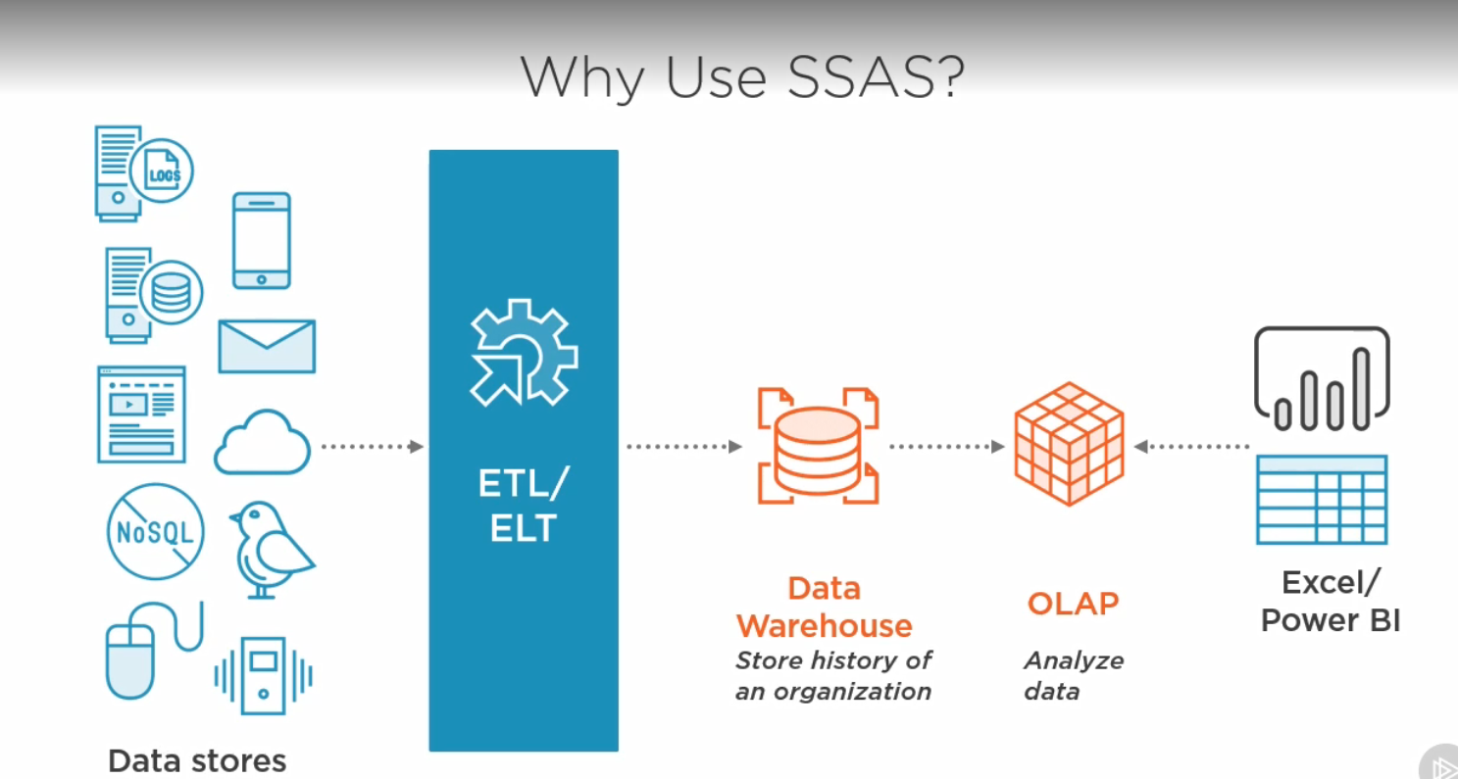
* Self service BI is when business users are actively involved in accessing and working with corporate data.
* Tabular was introduced in 2012 by Microsoft to enable users to write back to source.
* Corporate BI includes Tabular and Cubes/MDX.
* Self Service BI includes Excel Power Pivot and Power BI.
* 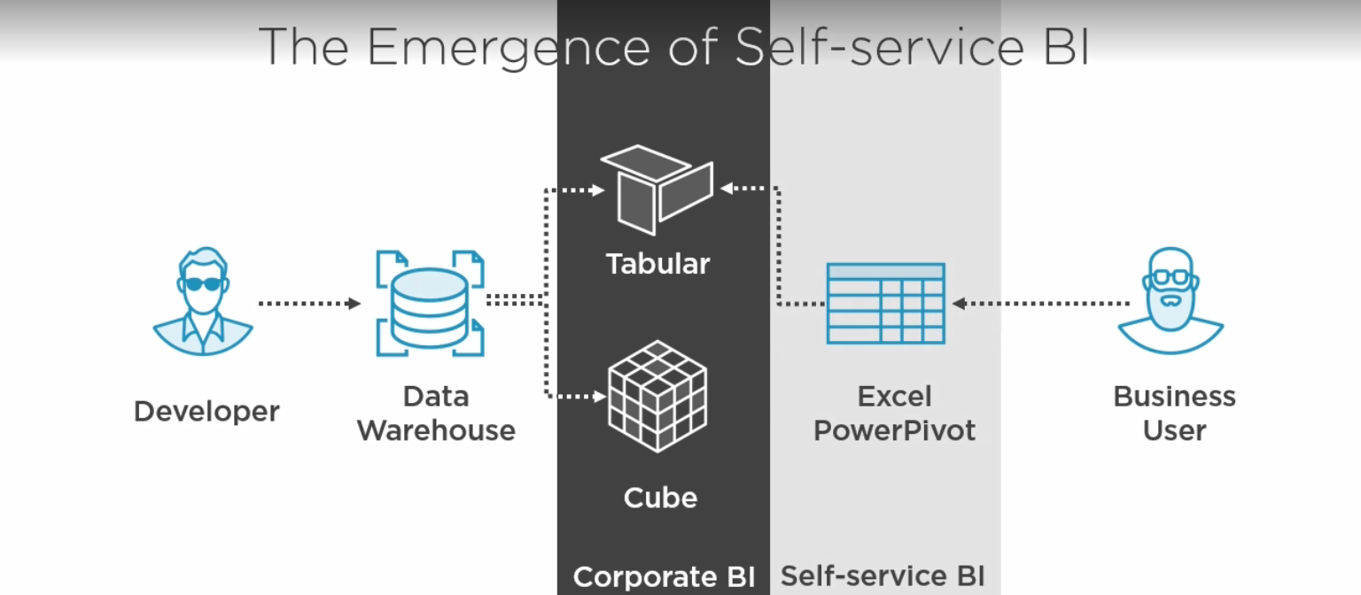
* Data Source for Tabular and MDX is a Data Warehouse.
* A KPI is used to measure business objectives. E.g comparing this months sales to previous years sales during the same month.
* Columnar databases are optimised for analytical reporting.

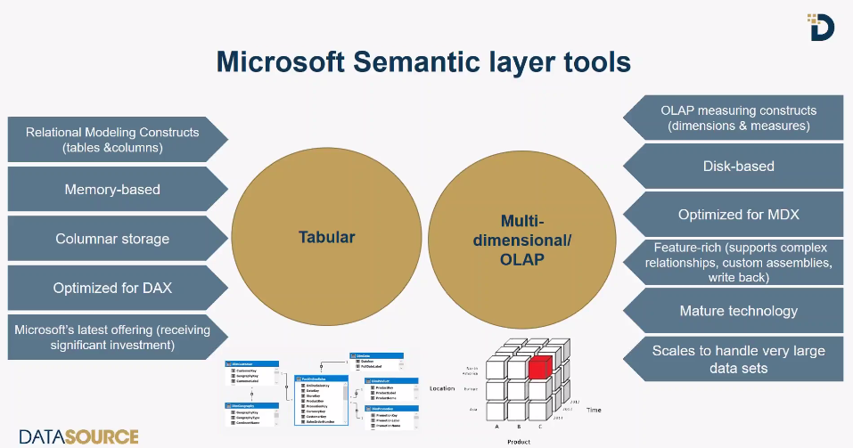

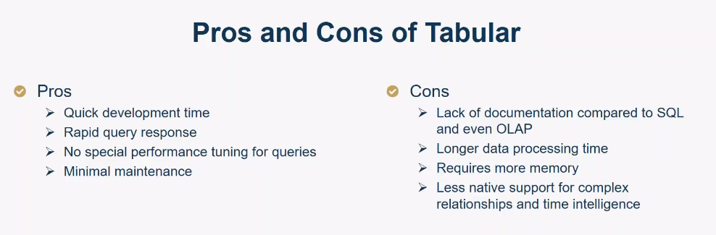

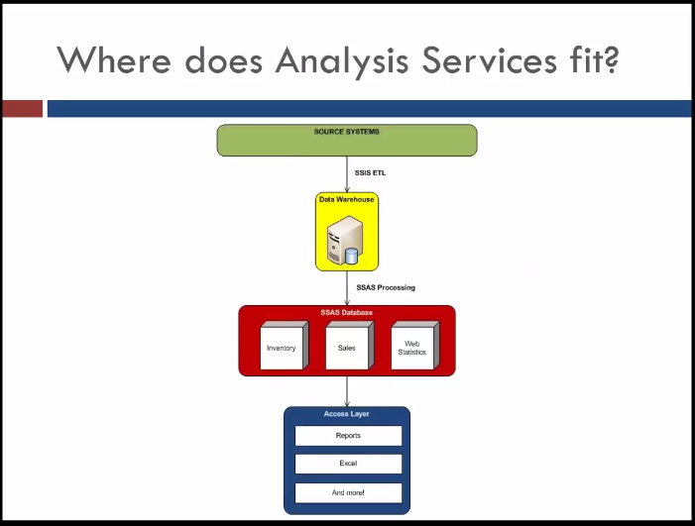

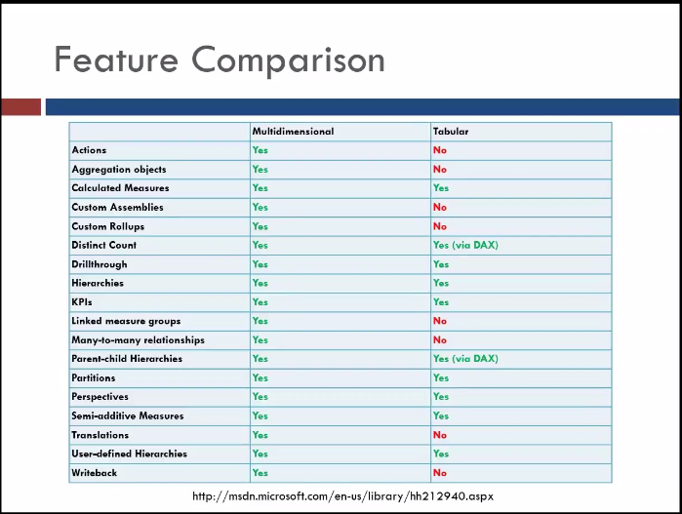

Fact table types

* Transaction Fact table
* Periodic Snapshot Fact table
* Accumulating Snapshot Fact table

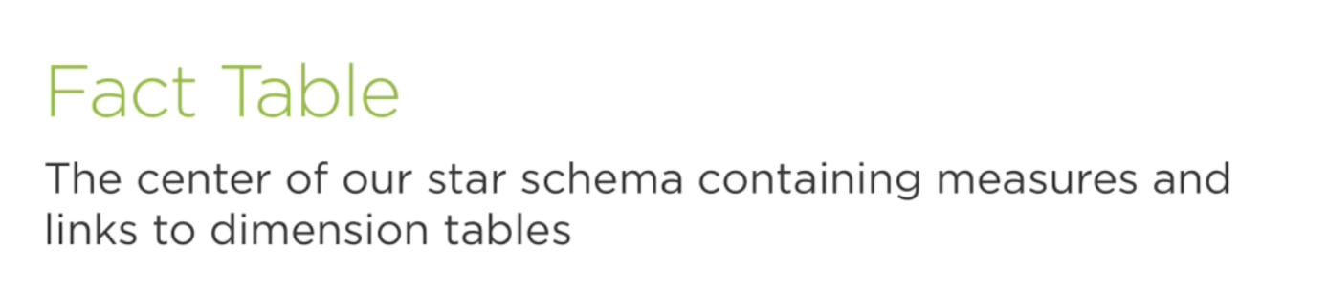

Stored procedures (Sprocs)

Comparing Data fetching options

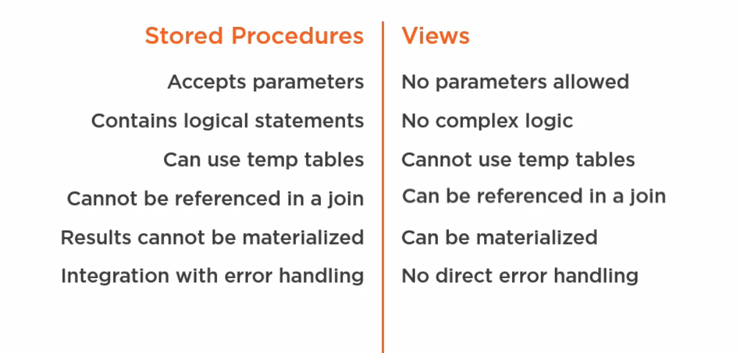

Purposes of a Stored Procedures (SPROC)

* Query data🡪returns results back to the client [DQL]
* Modifying Data🡪performing Updates Inserts and Deletes [DML]
* Lower complexity

Check this out

